

Headteacher
Miss C. Fletcher

Hindley Green CP School
Thomas Street
Hindley Green
Wigan
WN2 4SS
Tel: 01942 255406

ABSENCE REQUEST FORM
Pupil Details
Name Date of Birth

Class Class Teacher

Address

ABSENCE INFORMATION
Absence from Date of return

Number of school days absent

Destination / Exceptional reason for absence:

All absences requests are at the headteacher’s discretion and may be authorised under exceptional circumstances.
I understand that keeping my child out of school for any longer than agreed or if my request is not granted, will result in the absence being recorded as unauthorised. This may result in action being taken against me for non-school attendance.

Parent/Carer Name

Relationship to child

Parent/Carer address (if different to above)

Contact Number

Email address

Please provide details of all attendees including adults and children and reasons for requesting this leave of absence and in particular any ‘exceptional circumstances’. If necessary, please provide any documentary evidence in support of your request.

I certify that the information provided on this form is correct. I understand that the school reserves the
right to issue a penalty notice or remove my child from the school register for unauthorised leave

Signature: Print name

Date of request

Guidance Notes
– Please ensure this form is completed at least 1 month prior to requesting leave. Completing this form does not mean your request has been approved.
– The Education (Pupil Registration) Regulations 2024 states that headteachers may not grant any leave of absence during term time.
– If your leave of absence request is not approved, then the absence will be marked as ‘unauthorised’ on the attendance register.
– For such ‘unauthorised’ absence, you may be liable to be issued with a penalty notice (fine). The fine is £80 per parent per child if paid within 21 days, increasing to £160 per parent per child if paid between 21 and 28 days. If one or both parents fail to pay the penalty notice in full, then you may be prosecuted. The school also reserves the right to remove your child from the roll of the school. Where this happens, please be aware that it may not always be possible to re-admit your child to the school.

Exceptional Circumstances: In considering whether any ‘exceptional circumstances’ apply, the Headteacher will consider if the reasons are rare, significant, unavoidable, and short. The Headteacher will also take into consideration the factors listed below:
– can the event for which the absence requested can be reasonably taken during school holidays?
– levels of attendance and unauthorised absence over the last 12 months
– any leave of absence taken previously
– whether the leave is during the exam period, controlled exam periods or will result in not meeting
assessment deadlines
– age and year group of the pupil

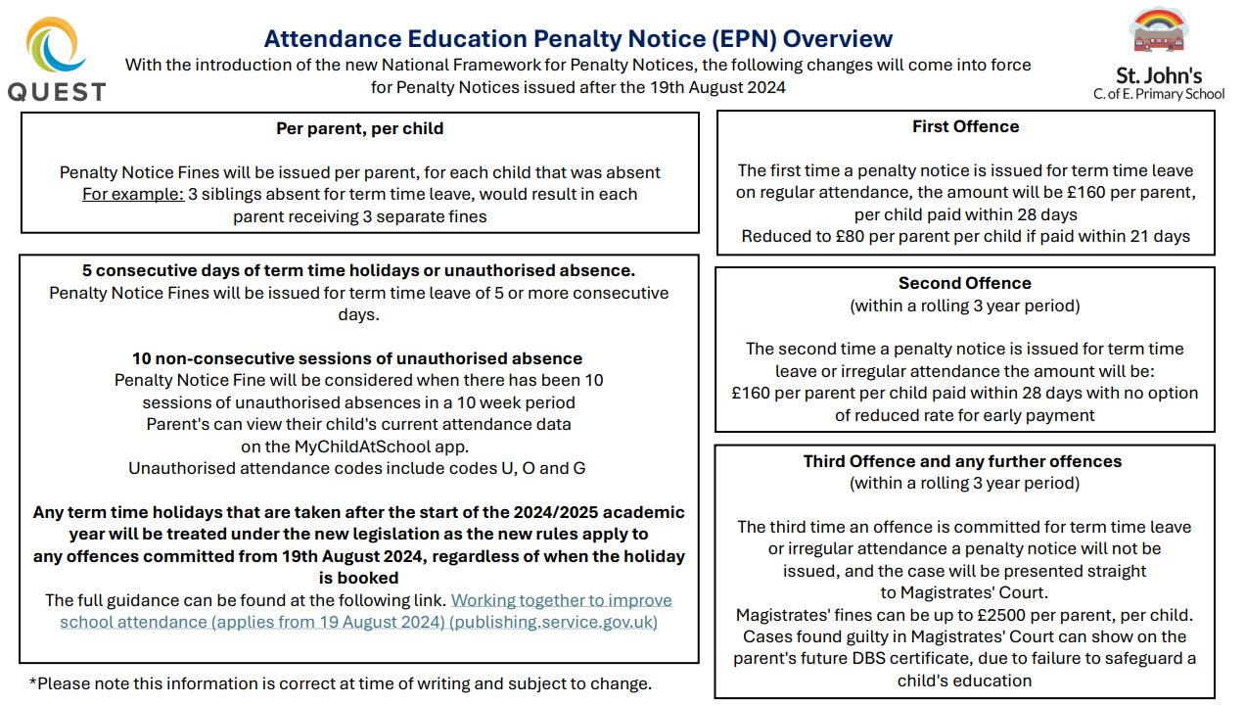
jjjjjjjjjj

TO BE COMPLETED BY SCHOOL
Child’s current overall attendance

Authorised: Y / N (please circle) By

Position Date

